MINDX SERVICE AI

DAY 2 ASSIGNMENT REPORT

Submitted by
Santhoshkumar D
B.Tech Information Technology
Rajalakshmi Engineering College

Date : 06/04/2026

Objective:
To enhance the backend system by integrating AI-based response generation and implementing smart escalation logic for handling critical user queries.

Requirements:
1. Integrate AI response system
2. Store both user and AI messages
3. Implement escalation logic for specific keywords
4. Return AI-generated response to frontend

Expected Flow:
User → Ticket Creation → Store Message → AI Response → Store AI Message → Return Response
Technologies Used:
- Java
- Spring Boot
- REST APIs
- OpenAI API
- MySQL

Features Implemented:
- Integrated AI-based response system (simulated / API-based)
- Stored both USER and AI messages in database
- Implemented escalation logic:
• "refund"
• "complaint"
• "angry"
- Automatically updates ticket status to NEEDS_HUMAN
- Returns AI-generated response to user
- Maintains full conversation history

System Flow:
1. User sends query via API
2. Ticket is created with status OPEN / NEEDS_HUMAN
3. User message is stored in Message table
4. AI generates response
5. AI message is stored in Message table
6. AI response is returned to user

User → Controller → Service → AI Service → Database → Response

Escalation Logic:
If user query contains keywords like:
- refund
- complaint
- angry

Then:
Ticket status is automatically set to NEEDS_HUMAN
Example:
Input: "I want refund"
Output: Status = NEEDS_HUMAN

Screenshots:
Figure 1: POST request using Postman(AI response)
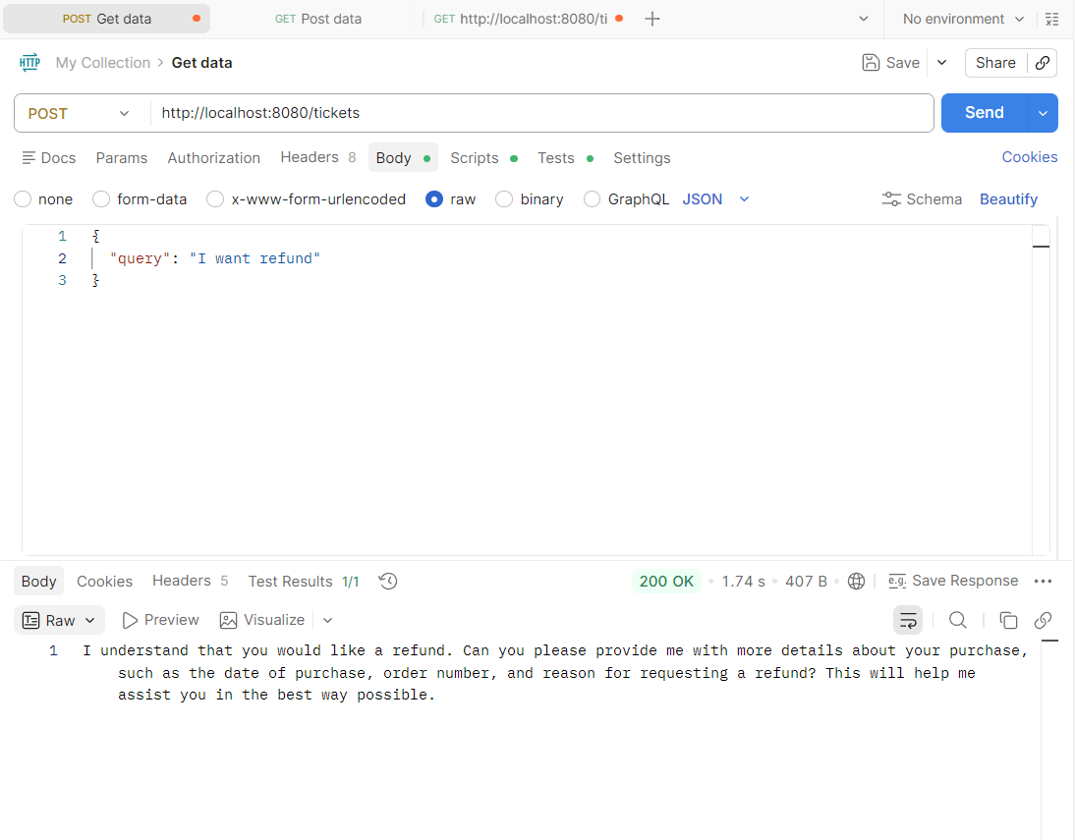
Figure 2: GET /tickets showing status = NEEDS_HUMAN
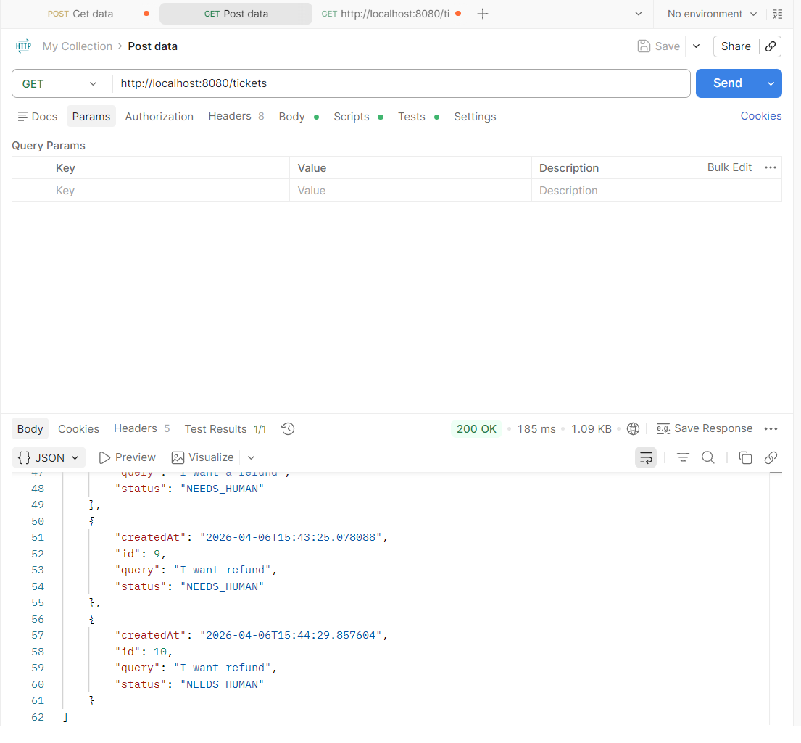
Figure 3: GET /tickets/{id} showing messages
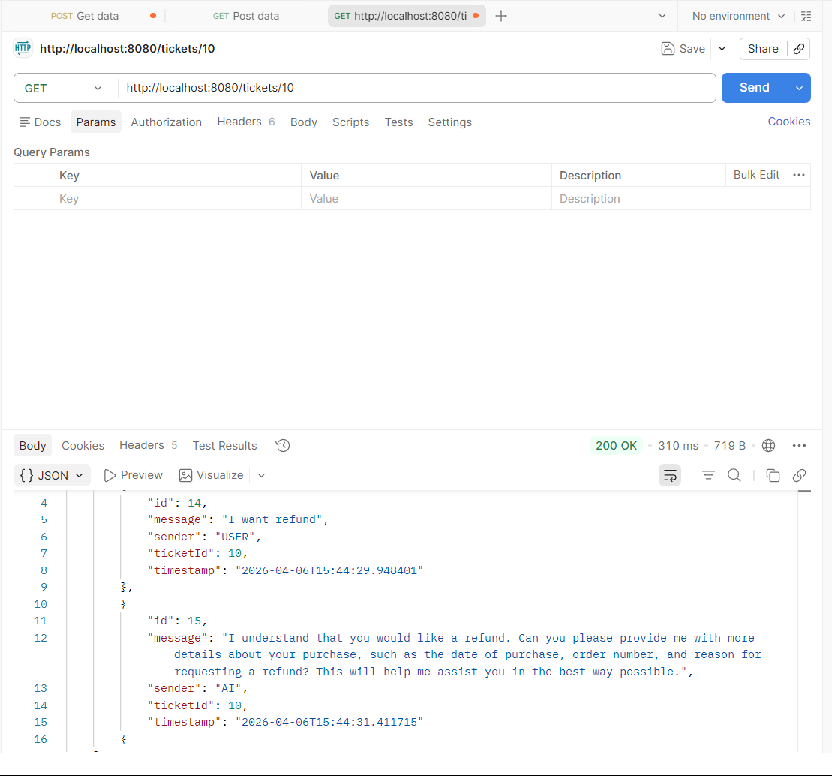

Database:
The data is stored in MySQL database with two tables:
- Ticket table
- Message table
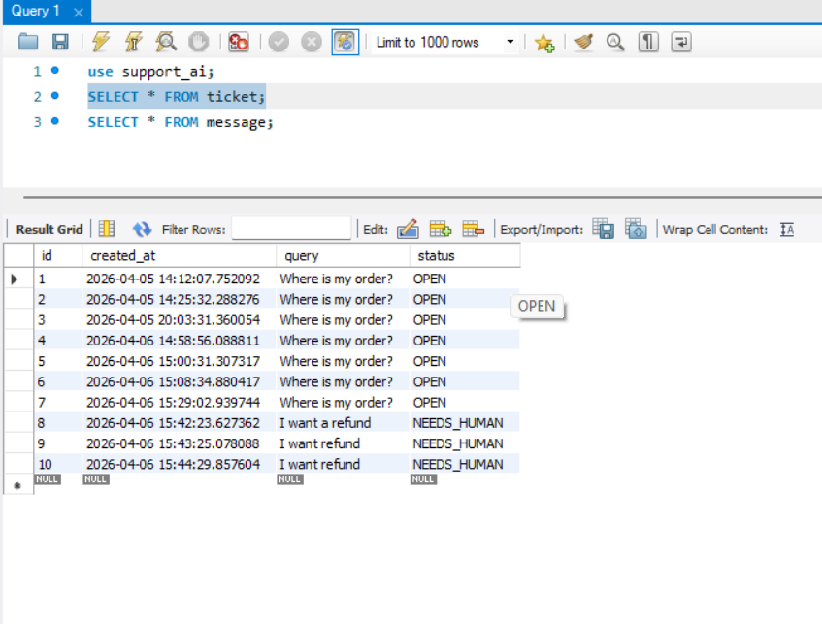
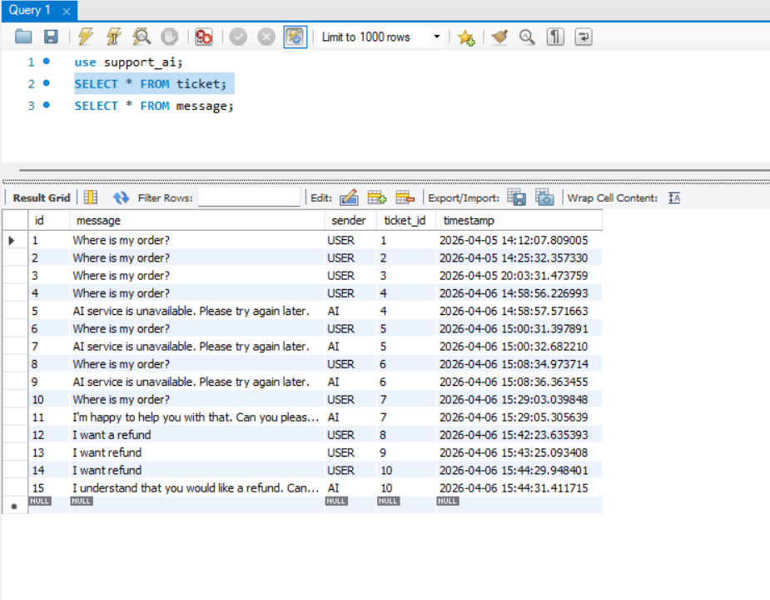

Challenges faced:
- Handling API quota limitation in OpenAI
- Debugging API integration errors
- Implementing fallback AI response
- Ensuring proper message storage flow

Conclusion:
Successfully implemented an AI-based response system and escalation logic. The system now behaves like a real-world support platform with intelligent response handling and ticket prioritization. This implementation demonstrates backend system design, AI integration, and real-time decision-making logic.

GitHub Repository:
https://github.com/SANTHOSHDEV22/mindx-support-ai

